**Impacts of Airbnb Regulation in Berlin, Barcelona, San Francisco, and Santa Monica**

*Introduction*

Many cities around the world have grown intolerant to local residents hosting their homes on Airbnb. They cite a myriad of problems that comes from Airbnb properties—unruly tourists, upward pressure on local housing rents, and weakening of the local community fabric. Furthermore, cities and the hotel industry have put particular pressure on Airbnb to keep professional hosts, or multi-unit hosts, from running illegal hotels. Airbnb has responded saying that it wants to be a platform for helping middle-class families help make ends meet.[1]

Each city has employed its own strategy in combatting the intrusion of Airbnb. Some have taken to fining hosts, others have placed caps on how many days permanent residents can use their properties as Airbnb accommodations. This analysis looks at a handful of cities engaged in a confrontation with Airbnb and assesses how well each city’s regulations have worked in reining in the growth of Airbnb and restricting professionals from taking advantage of it.

This analysis uses the Monthly Property Performance Data from AirDNA to track the evolution of listings and other metrics over time. AirDNA counts listings as active during a month if they are listed on the Airbnb site during the month or have at least one reservation day during the month. This has two advantages—first, it prevents AirDNA from capturing zombie listings that are no longer active on the Airbnb platform, but have not been removed. Second, it captures listings that are reserved but not scrapable, which is critical because properties do not have to show up on the Airbnb platform in order to be hosted if it was already reserved.

*Berlin*

Berlin has one of the strictest regulations against short term rentals in the world. Starting from May 1, 2016, Berlin banned hosts from renting out their homes to short-term visitors unless they occupied at least 50% of the homes themselves. The fine for hosting entire homes after the ban is approximately $100,000.[2]

AirDNA’s unique data collection methodology generates a picture of what is happening to Airbnb listings in Berlin that is consistent with the facts. The Berlin ban should have only affected the number of entire home listings after May 1, 2016 and not touched the growth of hosting private or shared rooms. Figure 1a shows the rise of the number of entire home listings flattened after May 1, 2016, but the shared home listings continued to rise.

This analysis uses a difference-in-differences methodology to tease out the impact of the Berlin ban on short term vacation rentals. As previously noted, Figure 1a demonstrates the flattening of entire home listings after May 1, 2016 while the shared home listings continued to grow. The identification strategy is that absent the May 1, 2016 ban on entire home listings, entire home listings would have followed the growth trajectory of shared home listings.

This common trends assumption can be inspected by looking at how closely the trajectories of entire home listings and shared home listings moved prior to May 1, 2016. Prior to May 1, 2016, the trajectory of entire home listings and shared home listings were 99% correlated. After May 1, 2016, the two series were only 22% correlated. Figure 1b shows what the entire home listings trajectory would have looked like if it had followed the growth trajectory of shared home listings. The difference-in-differences methodology then calculates the difference between what really happened and what would have happened to determine the impact of the Berlin ban.[3]

Other analyses have documented how the ban has decreased the number of Airbnb listings in Berlin. They report that listings fell 40% in a month.[4] This analysis adds additional specificity and context. First, Figure 1c shows that monthly listings fell approximately 49% after the ban. Perhaps due to the decrease in supply or hosts shifting the burden of increased risk in hosting to the consumer, the Average Daily Rate (ADR) charged by hosts increased by approximately 5%. As a result of increased prices and decreased listings, monthly reservation days fell by 59%. This ultimately corresponded to a 55% decrease in monthly revenue.

Berlin’s strategy to impose high, stiff fines seems to be particularly effective in rooting out professional hosts—or hosts who listed more than one property in a month. The number of monthly listings fell by 60%, which is over 10% more than the overall group. Consistent with the story that professional hosts are savvier in pricing for market supply and demand, they raised their prices by 9%, which is almost double the overall group.[5] As a result of the increased prices and the decreased listings, the number of reservation days fell by 63% and monthly revenue fell by 55%.

*Barcelona*

Barcelona has taken several steps to combat short term rentals. All holiday rentals in Barcelona require a tourist license. The city has, at times, frozen the issuing of tourist licenses to control tourism. At other times, they have taken to fining Airbnb for un-licensed listings on their website. This analysis focuses on the impact of freezing the issuing of licenses. As for the impact of fining Airbnb for un-licensed listings, it is unclear Airbnb has taken steps to remove listings from its website because of the fines. In fact, Airbnb said they would appeal the fines.[6]

On July 2, 2015 Barcelona’s new mayor suspended all new tourist accommodation licenses until it could reach a development plan.[7] The suspension was not only limited to Airbnb and home-sharing accommodations. It also included hotels, hostels, and the like. Eight months later, the new development plan was circulated in March 2016 and included a complicated set of licensing restrictions by city zones.[8] To avoid the complications of this new plan, this analysis ends in March 2015.

Prior to July 2, 2015 the previous mayor of Barcelona had already suspended licenses for a subset of neighborhoods in the city that were particularly congested with tourists. These neighborhoods were: el Eixample,  los de Vila de Gràcia, Poblenou, Camp d'en Grassot and Gràcia Nova, Poble Sec, Sant Gervasi-Galvany, Putget-Farró, Clot-Camp de l'Arpa and the nearby areas of Hospital de Sant Pau and Sants station.[9] These neighborhoods form the Already Frozen series in Figure 2a. The Newly Frozen series contains all neighborhoods that experienced a license freeze starting on July 2, 2015.

Figure 2a paints a clear picture. Prior to July 2, 2015, the Already Frozen and Newly Frozen trajectories almost completely overlap. In fact they are almost 100% correlated. The idea here is that before the July 2, 2015 freezing of tourist licenses, the Newly Frozen and Already Frozen trajectories move in concert because the freeze has not come into effect yet.

After July 2, 2015, the Newly Frozen series slightly pulls away. This is because the freeze impacts the Newly Frozen, but not the Already Frozen—the latter has already been frozen and does not change. Figure 2b shows that the percentage difference between the Newly Frozen and the Already Frozen is relatively flat prior to July 2015 and averages around 20%. After the jump on July 2015, the percentage difference reaches a new equilibrium and averages around 27%.

Figure 2c shows that the freeze led to a 6% increase in listings, which translated into an increase in available days of 7%.[10] One rationale for why the freeze increased listings is that it prevented hotels and the like to get licensed, which led Airbnb hosts to try and capitalize on the shortage in supply. In fact, international chains that did not have their management projects approved and licensed would be affected by the freeze.[11] However, this increase in listings did not seem to translate into more reservation days. There was no concomitant increase in demand. In fact, the freeze led to a marginally significant decrease in revenue—7%, which remains a puzzle.

The story with professional Airbnb hosts is much the same as with the overall group. They increased their listings by 5%. For them, monthly reservation days fell about 4%, which contributed to a decrease in revenue of about 9%. The puzzle persists as to why listings increase, but reservation days and revenue fall.

*San Francisco*

In October 2014, San Francisco passed a law that legalized short-term rentals if they are offered by permanent residents, are registered with the city, pay a hotel tax, and carry $500,000 in liability insurance. The law further stated that entire home rentals would be capped at 90 per year, but owner occupied rentals, or shared homes, would not face a cap. This analysis focuses on estimating the impact of the 90 day cap on entire home rentals in San Francisco that went into effect on February 1, 2015.[12]

This analysis is particularly important as it comes on the heels of a measure to restrict all short-term rentals—entire or shared home—to 60 days a year.[13] This measure was ultimately vetoed by the mayor.[14] But, the threat of additional caps remain.

As with the analyses in previous cities, this analysis also takes a difference-in-differences approach. Since the 90 day cap only impacts entire home rentals, when compared to shared home rentals, only the number of entire home listings should be impacted after the law went into effect in February 2015. Furthermore, prior to February 2015, the entire home listings trajectory and the shared home listings trajectory should be the same assuming the only reason these two trajectories differ is because of the 90 day cap passed in February 2015. The shared home series can then be used as a counterfactual—enabling the calculation of how many listings there should have been absent the 90 day cap.

Figure 3a demonstrates that prior to February 2015, the entire home trajectory and shared home trajectory are 99% correlated. After February 2015, the two lines are still closely aligned, but visibly less so. In fact, they are 93% correlated after February 2015.

Figure 3b shows that the cap decreases the amount of listings by approximately 5%.[15] Also, the ADR increased by 12%. This decrease in supply and increase in price translates into a 15% decrease in reservation days.

The story for professional hosts is more severe. The 90 day cap seems to have effectively limited the operations of the professional hosts. They experience a 16% decline in listings, which is more than three times the overall group. From the decline in listings and 7% increase in price, they faced a 35% drop in reservation days and a 30% decrease in revenue.

*Santa Monica*

A new ordinance banning short term rentals of entire homes and restricting home-sharing to those who obtain a business license and pay a 14% hotel tax went into effect on June 12, 2015.[16] Those who violate the law can face fines up to $500.[17] This analysis compares entire home listings and shared home listings to determine what the impact of the law was on entire home listings. Again, it is assumed that entire home listings would have faced the same trajectory as shared home listings had the law not come into effect.

This is not a perfect comparison, however, because shared home listings faced its own regulations after the law that could make it a less desirable counterfactual. Obtaining a business license and paying a 14% hotel tax are deterrents to hosting. Therefore, the findings could be conflating the effect of the ban on entire home listings with the effect of the regulations on shared home listings. If the effect of the law on shared homes is to reduce the number of shared home listings, we can take this analysis as a conservative estimate of the impact of the ban on entire home listings.

Figure 4a shows that prior to June 12, 2015, entire home listings and shared home listings track closely. They are 94% correlated. After June 12, however, the two series move in opposite directions—with shared homes continuing to rise and entire home listings falling. They are -39% correlated.

Figure 4b shows that the law decreased listings of entire homes by 37%.[18] It also negatively impacted monthly revenue by 41%. Perhaps due to the shortage in supply of listings or the risk of listing entire homes, hosts increased their ADRs by 15%. As a consequence of both decreased listings and higher prices, monthly reservation days fell by 51% as well.

The story for professionals follows very closely. In fact, the pricing structure used by professionals did not deviate from the rest of the hosts as with some of the other cities. For example, professional ADR increased by 13% compared with 15% in the overall group. Revenue fell by 43% and number of entire home listings fell by 40%, which is in the same ball park as the overall group.

*Discussion and Conclusions*

The results seem to indicate that the most effective regulation in stymying Airbnb growth is directly going after Airbnb hosts. In the Berlin and Santa Monica scenario where both cities fined hosts of short-term vacation rentals, listings fell by 49% and 37%, respectively. Berlin’s exceptional success may be tied to its $100,000 fine. But, even with a $500 fine, Santa Monica has been able to limit the amount of offenders significantly. For both cities, the drop in percentage of listings was reflected in an equal-sized drop in revenue.

Interestingly, in the Barcelona case, limiting the licensing of tourist accommodations presents somewhat of a puzzle. The freezing of tourist accommodation licenses for vacation rentals—including hotels, bed and breakfasts, hostels, and the like—actually increased the number of Airbnb listings in the city. One interpretation is that Airbnb and hotels are substitutes. If the threat for a hotel violating the freeze is more than the threat for an Airbnb host violating the freeze, there might be a surge in listing on Airbnb. However, it does not explain why monthly revenues marginally fall.

For San Francisco, the 90 day cap on renting entire home listings posted a 5% decrease in listings. Compared with fining offenders in the Berlin and Santa Monica cases, this is a modest decrease. Furthermore, there was no significant decrease in revenue in San Francisco because prices adjusted upwards and compensated for the drop in listings and reservation days.

Berlin and San Francisco seem most successful in going after professional hosts. In Berlin, the fine led to a 60% decrease while the overall group posted a 49% decrease. Not surprisingly, professional hosts were able to adjust their price to compensate for the decrease in listings and their monthly revenue fell by 55%, which is the same amount as the overall group. For comparison, in Santa Monica, where hosts are also subject to a fine, the regulations had almost the same effect on professionals and the overall group. The one factor that sets Berlin apart from Santa Monica is the sheer magnitude of the fine. This could be a differentiating factor.

San Francisco featured the 90 day cap on entire home listings and was also successful at deterring professional hosts. They faced a 16% decrease in monthly listings compared with a 5% decrease in the overall group. Furthermore, the number of reservation days fell by 35%, which is double the overall group. This contributed to a 30% decline in monthly revenue.

It seems that cities who go after individual hosts with fines like Berlin and Santa Monica seem to be posting the greatest success in deterring the overall number of Airbnb listings. In the particular case of targeting professionals, steep fines and caps seem most effective. In the literature review conducted for this analysis, it seems inconclusive whether going after Airbnb itself is as effective. This is a point for further research.

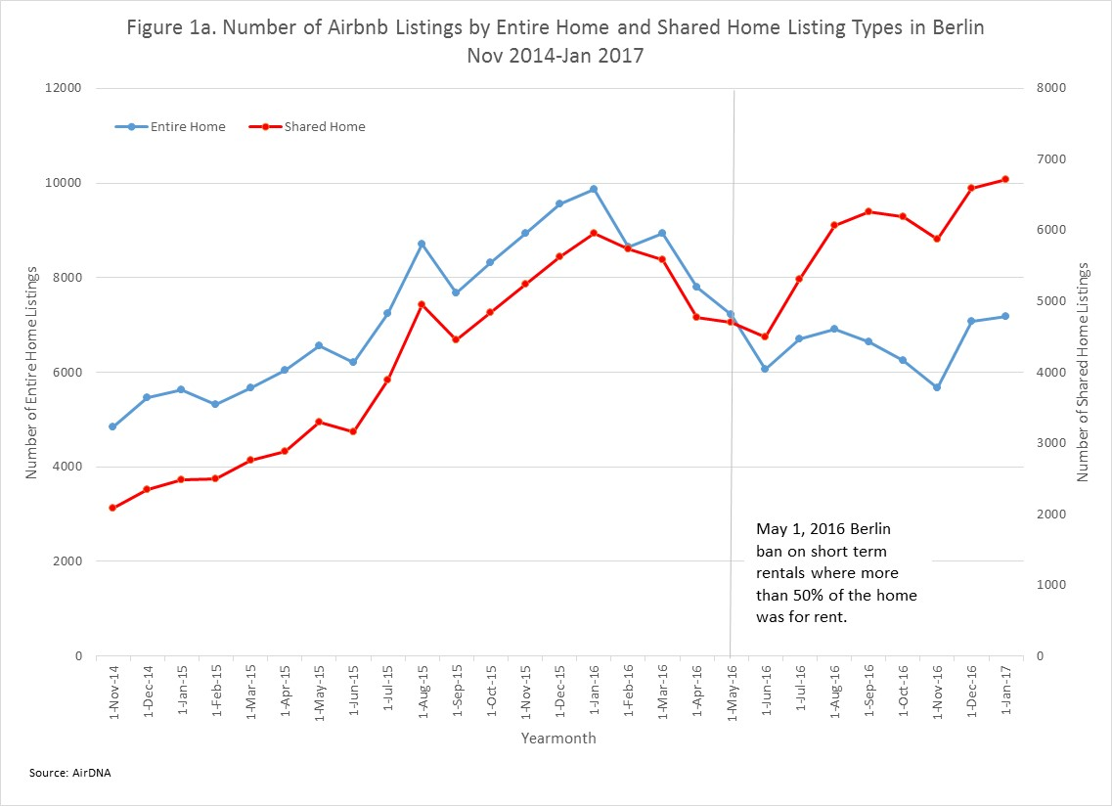

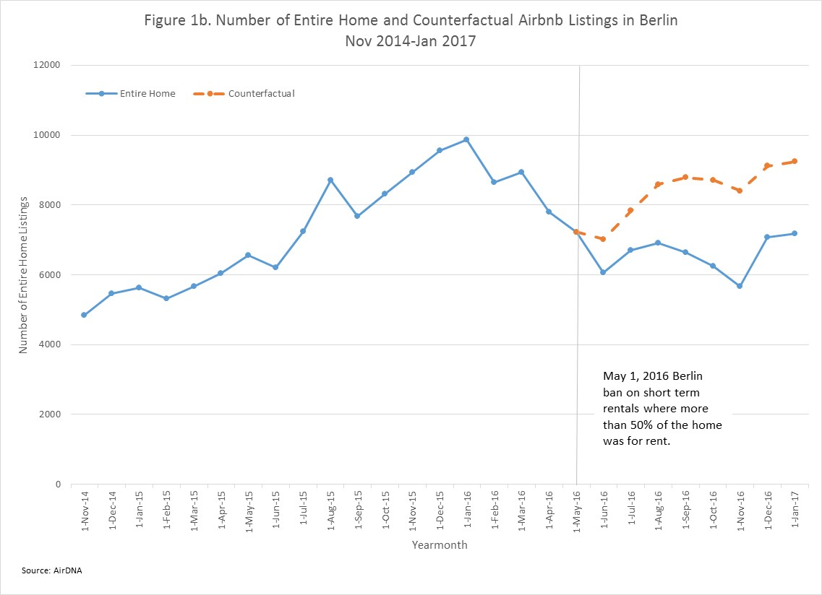

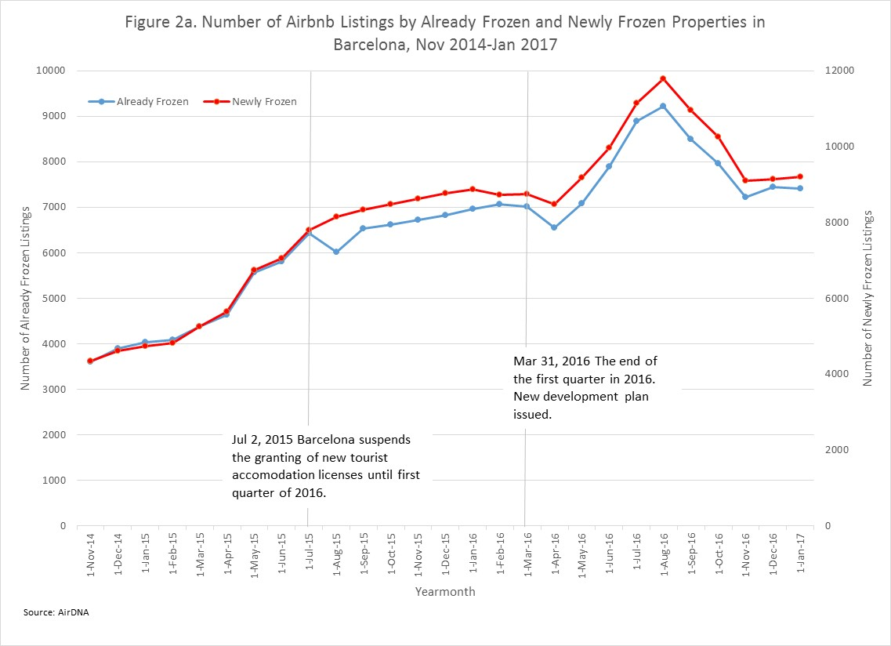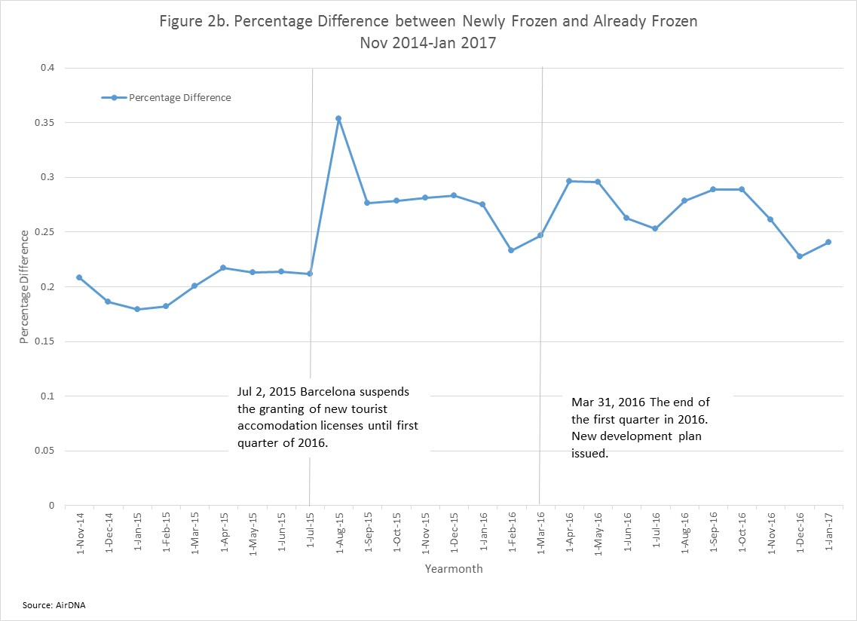



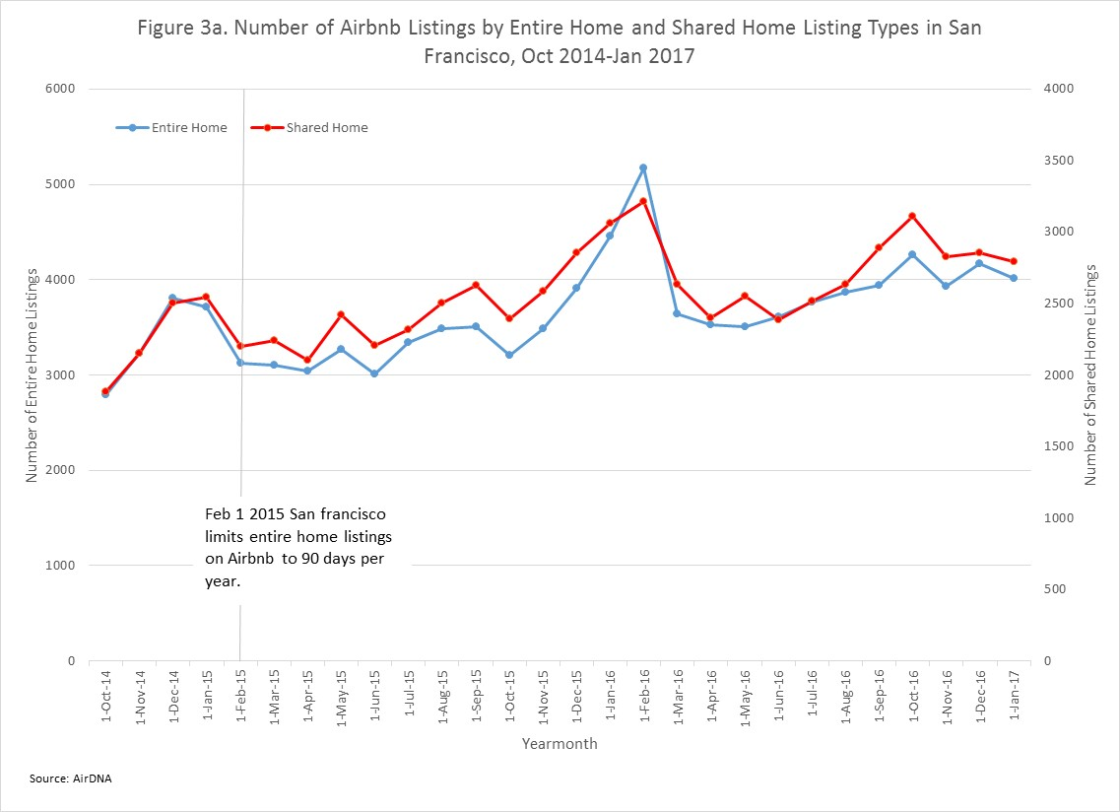



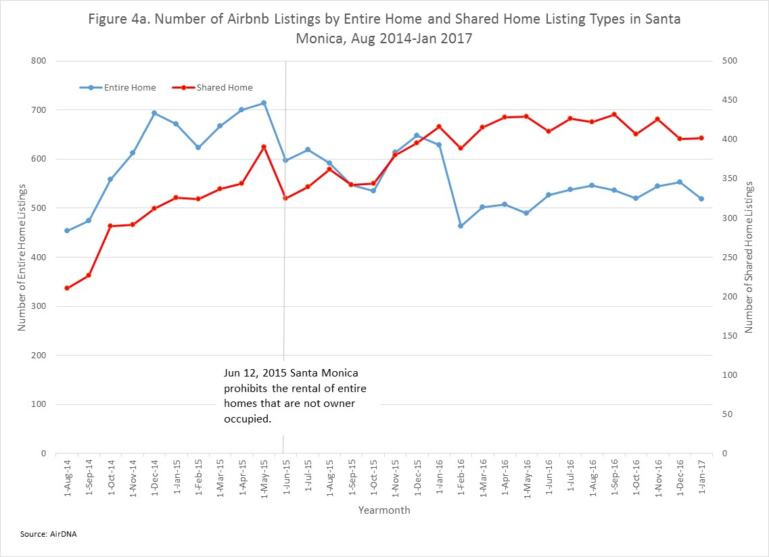



1. https://www.wsj.com/articles/hoteliers-cast-airbnb-as-fast-growing-professional-rival-1489084447
2. http://www.citylab.com/housing/2016/12/berlin-has-the-worlds-toughest-anti-airbnb-laws-are-they-working/509024/
3. The regression equation estimated is $Y_{et}=α+β{Treat}_{e}+γ{Post}_{t}+δ_{rDD}\left({Treat}_{e} × {Post}_{t}\right)+ϵ_{dt}$, where ${Treat}_{e}$ equals 1 if listing is for an entire home, ${Post}_{t}$ equals 1 if listing is after May 1, 2016. Standard errors are clustered by yearmonth.
4. http://www.citylab.com/housing/2016/04/airbnb-rentals-berlin-vacation-apartment-law/480381/
5. https://www.nytimes.com/2017/01/11/technology/personaltech/the-guide-to-being-an-airbnb-superhost.html?_r=0
6. https://www.ft.com/content/21a7e004-b253-11e6-9c37-5787335499a0
7. http://www.reuters.com/article/us-spain-tourism-barcelona-idUSKCN0PC14920150702
8. http://exnovo-rehs.com/en/permites-ouverture-hotels-barcelone-situation-mars-2016/
9. https://www.spain-holiday.com/rentalbuzz/barcelona-suspends-the-issue-of-further-holiday-rental-licences-for-six-months
10. The regression equation estimated is $Y_{et}=α+β{Treat}_{e}+γ{Post}_{t}+δ_{rDD}\left({Treat}_{e} × {Post}_{t}\right)+ϵ_{dt}$, where ${Treat}_{e}$ equals 1 if the neighborhood is Newly Frozen, ${Post}_{t}$ equals 1 if listing is after July 1, 2015 and before March 31, 2016. Standard errors are clustered by yearmonth.
11. http://exnovo-rehs.com/en/permites-ouverture-hotels-barcelone-situation-mars-2016/
12. <http://www.sfgate.com/business/article/Supervisors-approve-Airbnb-law-5807858.php>
13. http://www.theverge.com/2016/11/14/13632004/airbnb-san-francisco-rules-cooperate-register
14. https://skift.com/2016/12/11/san-franciscos-mayor-vetoes-regulations-on-airbnb-and-other-short-term-rentals/
15. The regression equation estimated is $Y_{et}=α+β{Treat}_{e}+γ{Post}_{t}+δ_{rDD}\left({Treat}_{e} × {Post}_{t}\right)+ϵ_{dt}$, where ${Treat}_{e}$ equals 1 if listing is for an entire home, ${Post}_{t}$ equals 1 if listing is after Feb 1, 2015. Standard errors are clustered by yearmonth.
16. http://www.npr.org/sections/thetwo-way/2015/05/13/406587575/santa-monica-cracks-down-on-airbnb-bans-vacation-rentals-under-a-month
17. http://www.scpr.org/news/2016/07/27/62988/why-airbnb-has-paid-20-000-to-the-city-of-santa-mo/
18. The regression equation estimated is $Y_{et}=α+β{Treat}_{e}+γ{Post}_{t}+δ_{rDD}\left({Treat}_{e} × {Post}_{t}\right)+ϵ_{dt}$, where ${Treat}_{e}$ equals 1 if listing is for an entire home, ${Post}_{t}$ equals 1 if listing is after Jun 1, 2015. Standard errors are clustered by yearmonth.